**Phase 5**

**Lesson 3**

**Create an IAM User**

Steps:

1. Selecting the IAM from the AWS Console

2. Navigating to the user creation page

3. Changing access permissions

4. Adding an identifier

**Step 1:** Selecting the IAM from the AWS console

* Login to your AWS console and search for IAM

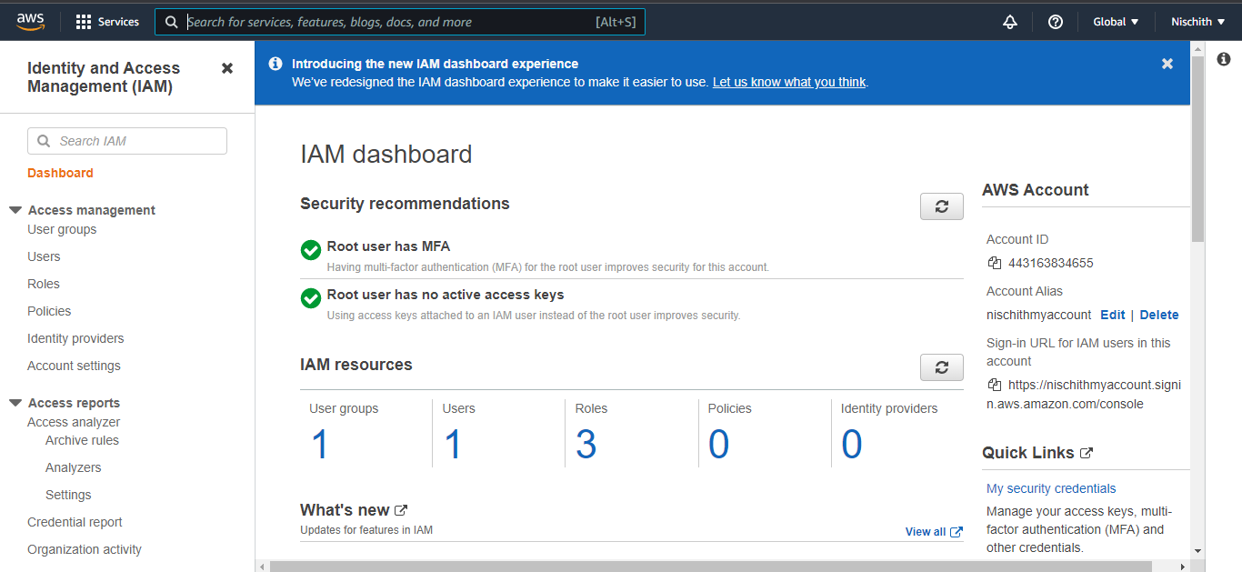

**Step 2:** Navigate to the user creation page

* Click on **Users** to redirect to the user creation page to create IAM users

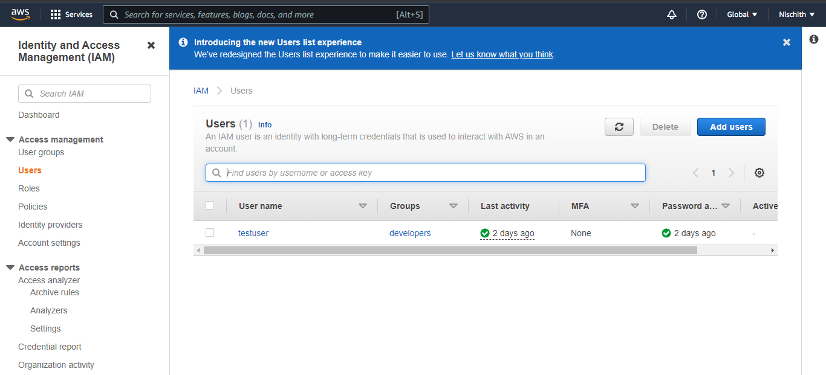

**Step 3:** Changing access permissions

Add username in the **User name\*** section. Select **AWS Management Console access** and select one of the ways to configure **console password**

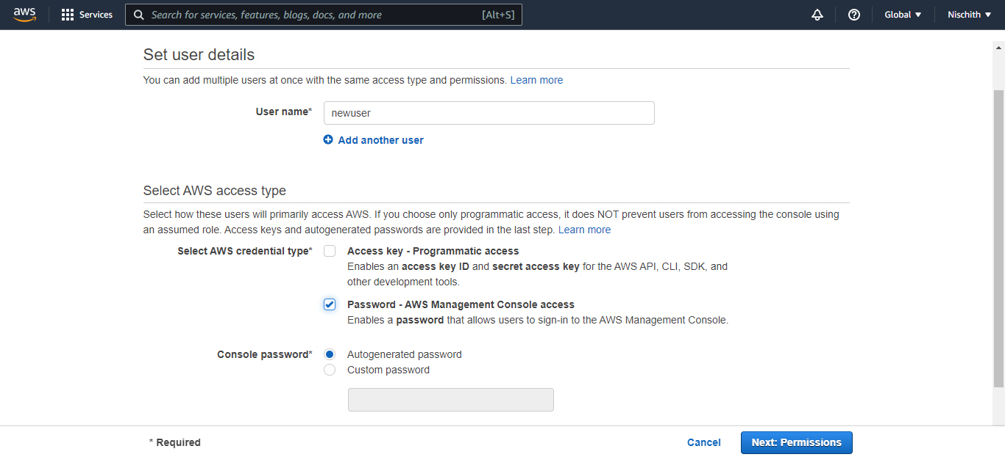

* Either we can add user to the created group or we can add policy as shown below:

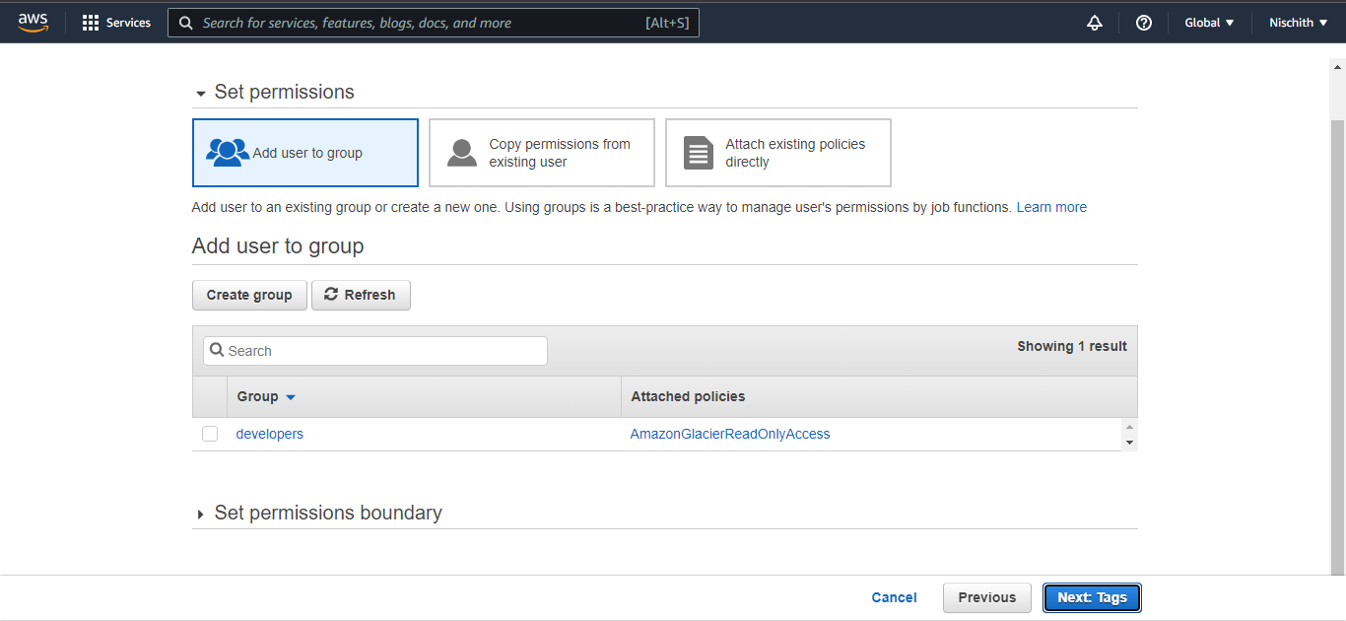

* In case a user needs to add a policy first, then he or she needs to search and then add policy to the user

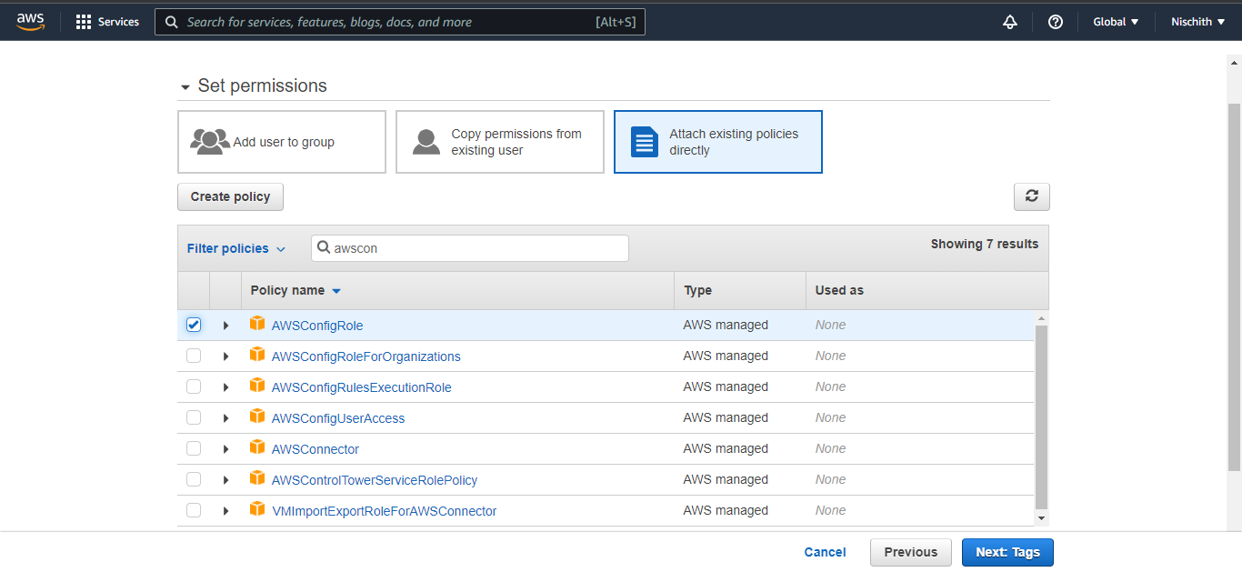

**Step 4:** Adding an identifier

* Add an identifier by adding key and value to tag each user as shown below:

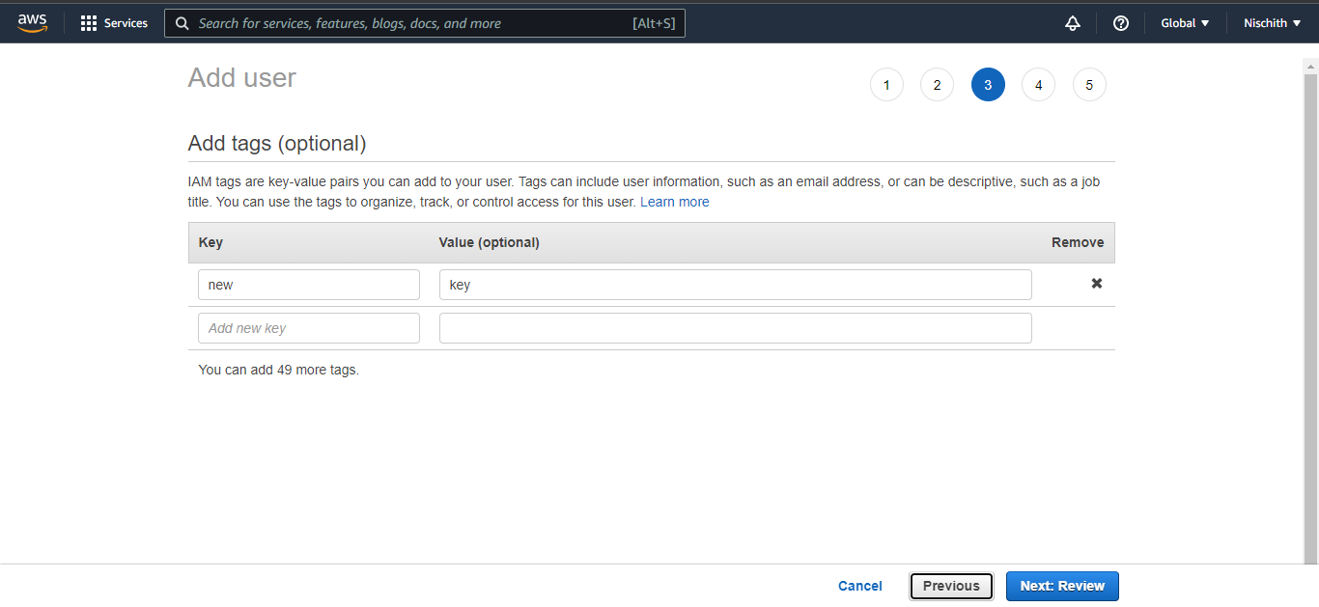

* Finally, it will create a user with a group or an added policy

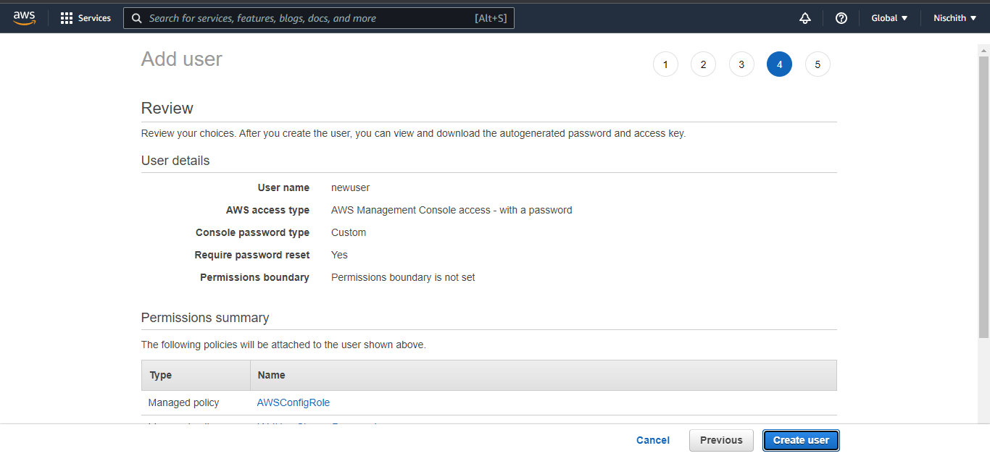

* On successful user creation, a URL will be created with which a user can login as an IAM user

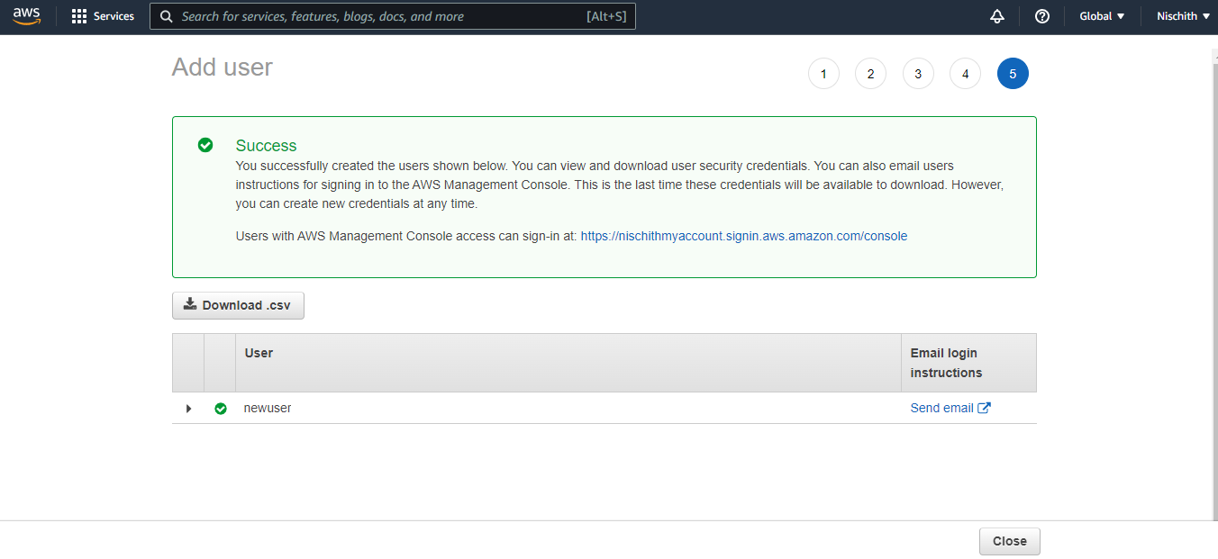

* The newly created user will be available on the dashboard as shown below:

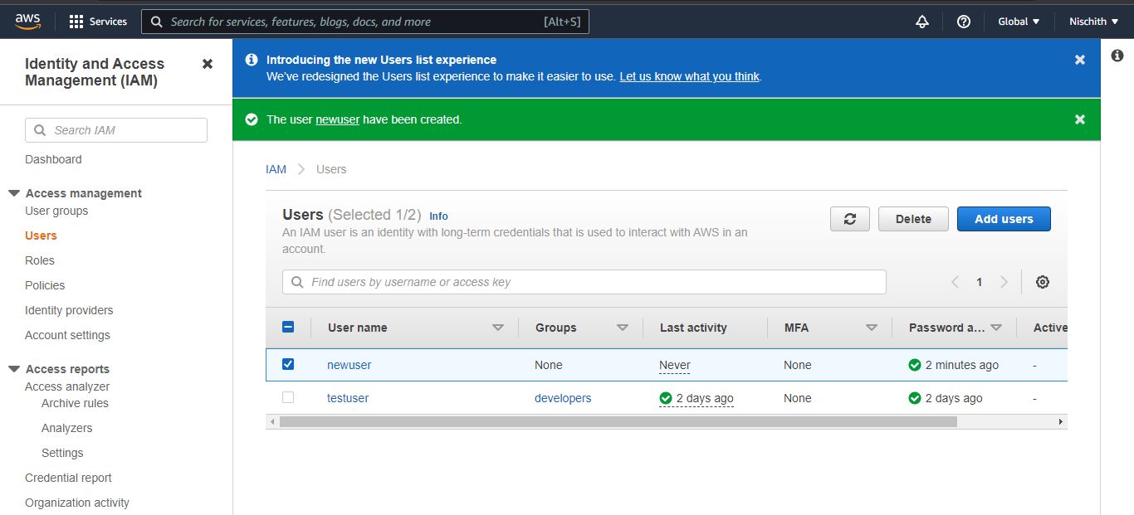

* By clicking on each user, you can see the key sign in the URL

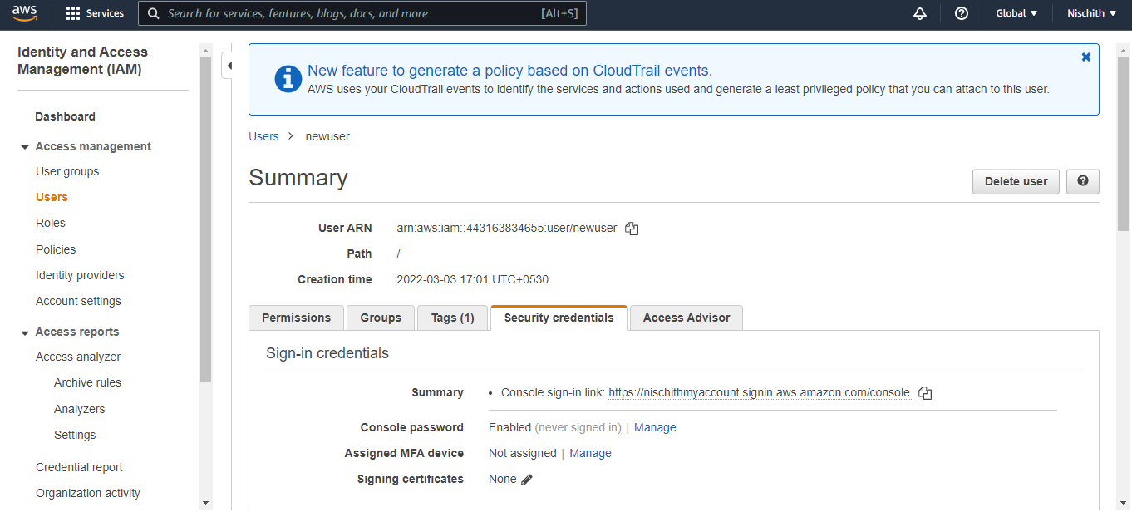

* By selecting a user, you can add that user to a particular group

